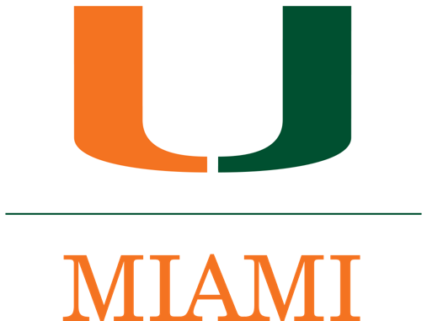
Technology Assistance Program (TAP)

The University of Miami’s Technology Assistance Program (TAP) offers a variety of workshops within the Learning Commons that enhance the existing academic services at the Richter Library by bridging the gap between academics and technology through guided consultations and workshops.

The following remote workshops are being offered during the Spring 2021 semester. To register, please click on the CLICK HERE of the workshop you wish to attend, and you will be redirected to the TAP Workshop page to complete your registration.

Spring 2021 TAP Workshops
DATE | TOPIC(S) | TIMES | LOCATION | REGISTER
Thursday,  March 4 | Microsoft Word Workshop | 2:00 p.m. –  3:00 p.m. | Remote Session via  Zoom | CLICK HERE
Thursday,  March 11 | Microsoft PowerPoint Workshop | 5:00 p.m. –  6:00 p.m. | Remote Session via  Zoom | CLICK HERE
Monday,  March 15 | Microsoft Excel Workshop | 2:00 p.m.–  3:00 p.m. | Remote Session via  Zoom | CLICK HERE
Wednesday, March 24 | Microsoft Word Workshop | 5:00 p.m.–  6:00 p.m. | Remote Session via  Zoom | CLICK HERE
Tuesday,  March 30 | Microsoft PowerPoint Workshop | 3:00 p.m. –  4:00 p.m. | Remote Session via  Zoom | CLICK HERE
Thursday,  April 8 | Microsoft Excel Workshop | 5:00 p.m.–  6:00 p.m. | Remote Session via  Zoom | CLICK HERE
Wednesday,  April 14 | Microsoft Word Workshop | 4:00 p.m. –  5:00 p.m. | Remote Session via  Zoom | CLICK HERE
Thursday,  April 22 | Microsoft PowerPoint  Workshop | 2:00 p.m. –  3:00 p.m. | Remote Session via  Zoom | CLICK HERE
Tuesday,  April 27 | Microsoft Word  Workshop | 5:00 p.m. –  6:00 p.m. | Remote Session via  Zoom | CLICK HERE

Visit it.miami.edu/tap for more information!

